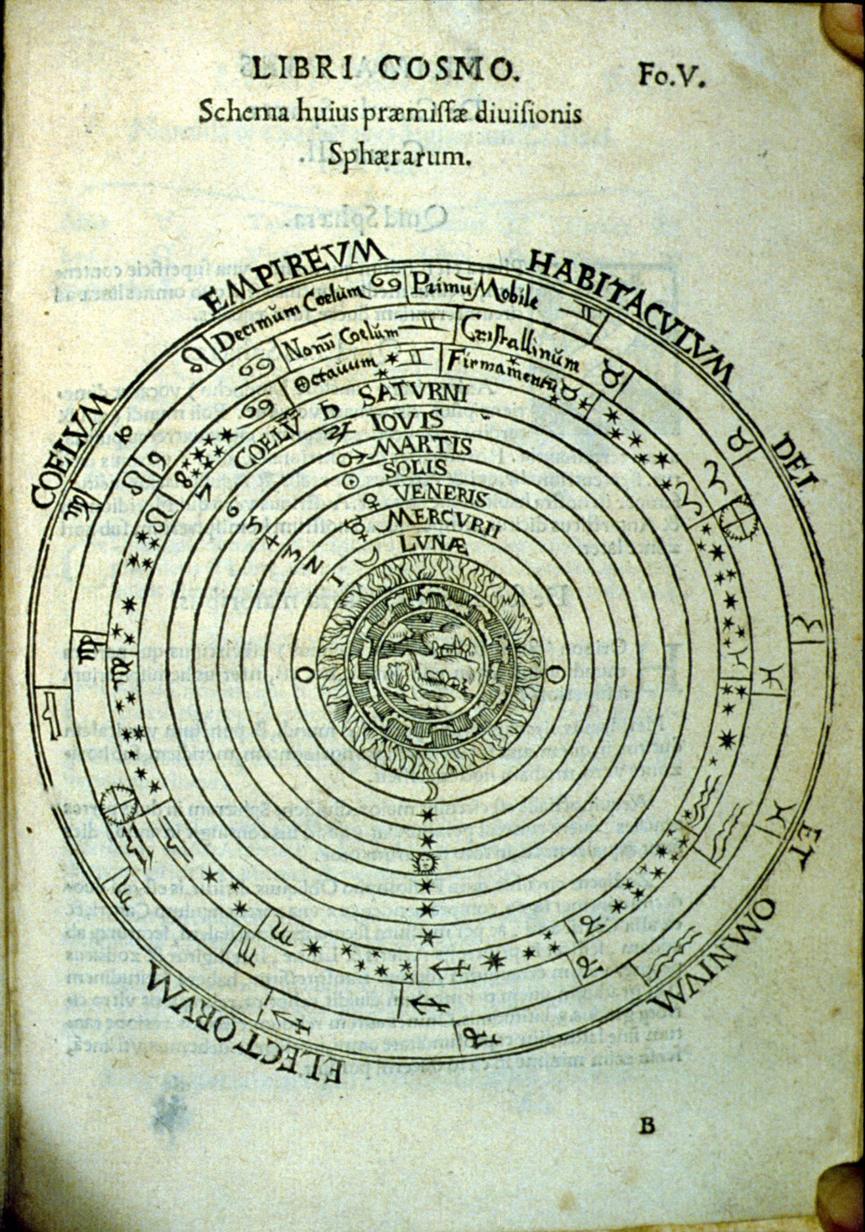
Aristotelian cosmos from Peter Apian, Cosmographicus liber, Antwerp 1584. Image courtesy of the History of Science Collections, University of Oklahoma Libraries.

